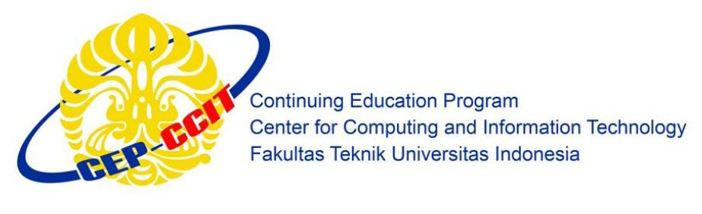

**Information Search and Analysis Skills**

**(ISAS)**

**IMPLEMENTATION OF APPLICATION BARCODE READER ON BARCODE SCANNER**

**Name : 1. Andika Saputra**

**2. Ugi Ispoyo Widodo**

**Faculty : Mrs. Emma Yulianti ST, MM**

**Semester : 3**

**Quarter : 6**

**Class : 3SC4**

**Gedung Pascasarjana Lt. 3 Fakultas Teknik Universitas Indonesia**

**Kampus Baru UI Depok 16424**

**PREFACE**

All praise and gratitude writer prayed to Allah the Almighty God who has given His grace and guidance. So we do not experience barriers to the completion of a paper entitled "Technology Architecture of Motherboard". In this occasion, in the writing of this paper the authors get a lot of support from various parties, therefore, the authors also wish to thank the infinite:

1. Our parents, that always giving us good support to the support in the form of moral and material support.
2. Dr. Aries Subiantoro, ST.,M.Sc. as Director of CCIT-Faculty of Engineering, University of Indonesia.
3. Mrs. Emma Yulianti ST, MM, as Our Lecture Course that has a lot to provide guidance, direction and inputs in the manufacture of this paper as well as in other fields.
4. Friends in arms that also specifies the motivation is always in the form of exchange of ideas, encouragement and other things in order to manufacture this paper.
5. Others Peoples who take holders who also helped in making this paper.

The authors recognize that this study is far from perfect and there are still many short comings, therefore the authors expect criticism and constructive suggestions to the perfection of this writing. Hopefully, this task can be useful and beneficial to readers and other researchers, especially students of CCIT-Faculty of Engineering, University of Indonesia and others who read this paper.

Depok, September 2015

The Authors

Table of Contents

CHAPTER I 1

INTRODUCTION 1

I.1. Background 1

I.2. Writing Objective 1

I.3. Problem Domain 2

I.4. Writing Methodology 3

I.5. Writing Framework 3

CHAPTER II 5

BASIC THEORY 5

II.1. Definition of Barcode 5

II.2. History of Barcode 6

II.3. Definition of Linear Barcode 7

II.4. Types and Uses For Of Linear Barcode 8

II.5. The Architecture of Linear Barcode 10

II.6. Barcode Scanner 13

II.7. Barcode Scanner as Reader of Linear Barcode 15

CHAPTER III 19

PROBLEM ANALYSIS 19

III.1. Requirements to Implementing Linear Barcode 19

III.2. Implementation of Application Barcode Reader on Barcode Scanner  20

IGII.3. Advantages and Disadvantage of Barcode Scanner 22

CHAPTER IV 23

CONCLUSION AND SUGGESTION 23

IV.1. Conclusion 23

IV.2. Suggestion 23

Bibliography 24

# Table of Figures

Figure 2.1 Example Linear Barcode from some product...........................................................5

Figure 2.2 Linear Barcode Example Code.................................................................................7

Figure 2.3 Architecture Based Linear Barcode........................................................................10

Figure 2.4 Basic Architecture Linear Barcode.........................................................................11

Figure 2.5 UPC 01....................................................................................................................12

Figure 2.6 UPC 01....................................................................................................................12

Figure 2.7 UPC CODE Example…..........................................................................................12

Figure 2.8 Single Point Led......................................................................................................13

Figure 2.9 LED’s Imager ……...............................................................................................14

Figure 2.10 Sensor Of Analog Signal......................................................................................15

Figure 2.11 Pen Type Reader...................................................................................................16

Figure 2.12 Laser Scanner.…...................................................................................................16

Figure 2.13 CCD Reader..........................................................................................................17

Figure 2.14 Omni Directional Reader.………….....................................................................17

Figure 2.15 Slot Reader…..………………..............................................................................17

Figure 2.16 Camera Based Reader…...………........................................................................18

Figure 3.1 Software Linear Barcode Reader…........................................................................20

Figure 3.2 Software Linear Barcode Reader…………............................................................20

Figure 3.3 Software Linear Barcode Reader…........................................................................21

Figure 3.4 Software Linear Barcode Reader…………............................................................21

# Table of Table

Table 2.1 Types And Uses For Of Linear Barcode....................................................................8